

**New 2020 Hyundai Sonata Makes Its North American Debut at the New York International Auto Show**

* The all-new Sonata embodies Hyundai’s Sensuous Sportiness design language with a sophisticated four-door-coupe look
* Hyundai’s third-generation vehicle platform enables improvements in design, safety, efficiency and driving performance
* Hyundai First: Sonata’s Digital Key allows the vehicle to be unlocked, started and driven without a physical key, via a smartphone
* Hyundai First: Hidden Lighting Lamps turn chrome when off and lit when on

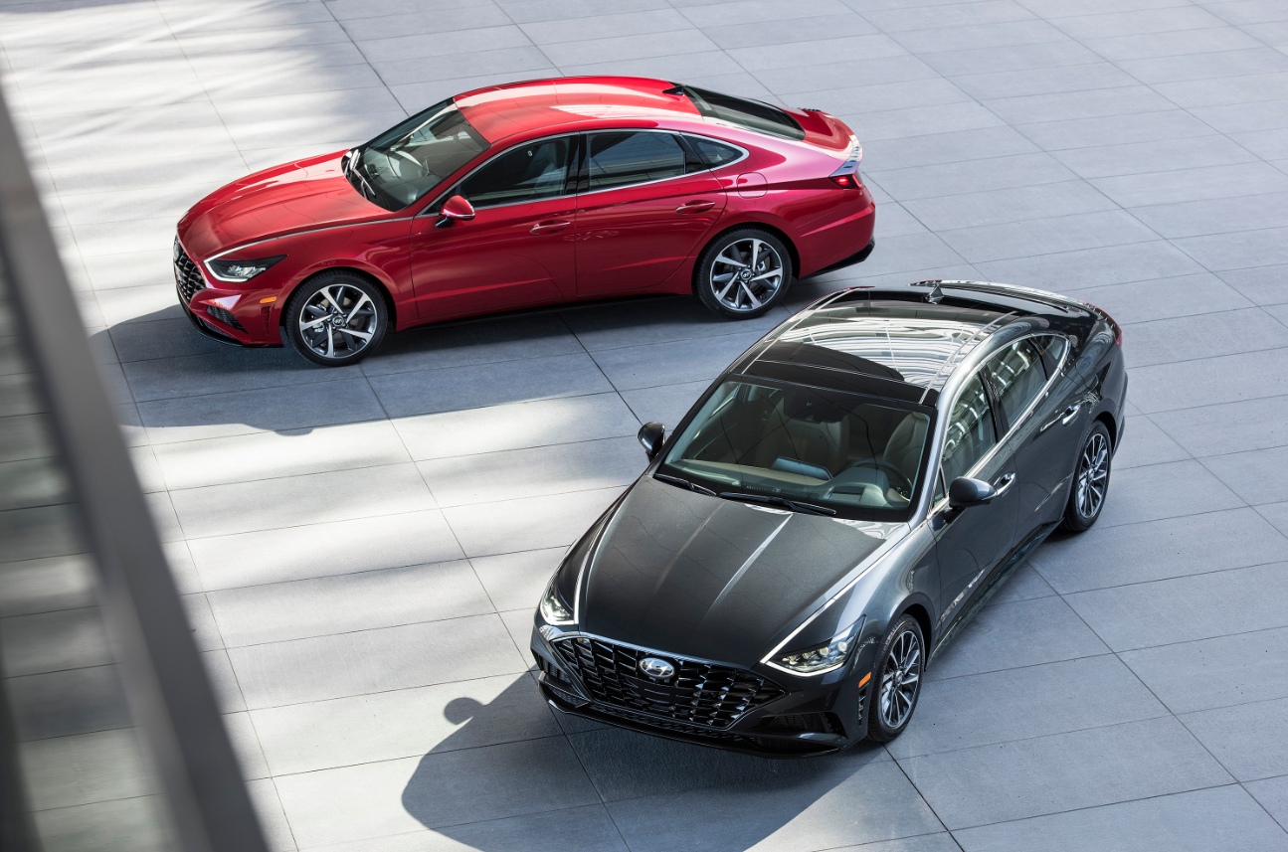

**NEW YORK, April 17, 2019** – Hyundai today introduced its all-new 2020 Sonata at the New York International Auto Show, marking the North American debut of Hyundai’s longest-standing and most successful model. The eighth-generation Sonata is unlike any of its predecessors, showcasing Hyundai’s Sensuous Sportiness design philosophy, an all-new Smartstream G2.5 GDI engine and segment-first technology that can be personalized. Production of the 2020 Sonata starts in September at Hyundai Motor Manufacturing Alabama and retail sales begin in October.

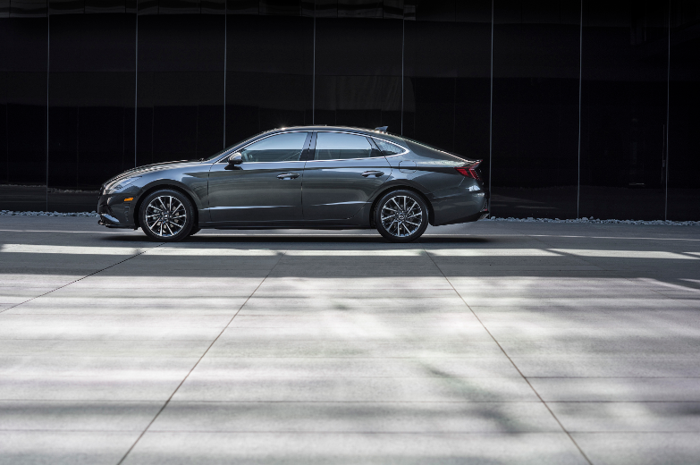

“Sonata is our signature product,” said Mike O’Brien, vice president, product, corporate and digital planning, Hyundai Motor America. “Having been one of our first and most successful nameplates, Sonata is our legacy, and it needs to be special and memorable in all attributes. Sonata signifies our vision for future Hyundai designs, great active safety systems and cutting-edge technology that is effortless.”

The new-generation Sonata is the first sedan designed with Hyundai’s Sensuous Sportiness design language. It is a fully transformed vehicle showcasing a sporty four-door-coupe look. The 2020 Sonata represents Hyundai’s new focus on creating emotional value using proportion, styling and technology. From the front, the 2020 Sonata is unlike any other Hyundai. The design is all-new, with cues that don’t immediately appear Hyundai-like and thus encourage customers to take a second look. The 2020 Sonata embodies the evolution of a new Hyundai design theme—a portfolio of vehicles that, like chess pieces on a board, look and behave differently, each with a clear role and function, but together exemplify a cohesive team.

Sonata has a distinct tension on the side, using a harmonious blend of two sharp character lines and pure volumes. Concave and convex forms are also carefully orchestrated to provide a sexy, coupe-like character.

The latest Sonata is the first model to be based on Hyundai’s new, innovative vehicle platform, which delivers increased strength and reduced weight to enable improvements in design, safety, efficiency and driving performance. The car uses an extensive application of advanced technologies to boost comfort, convenience and active safety. It is also the first model to premiere a new collaboration with Bose® to deliver an exceptional audio experience to customers.

“The Sonata holds a special significance for our company as one of the longest-standing and most successful models in the global market,” said Albert Biermann, president and head of R&D Division, Hyundai Motor Group. “The new-generation Sonata is a fully transformed vehicle packed with advanced personalization technology, a new platform and an array of ADAS technologies. We are confident that our customers will be pleasantly surprised by this innovative new model.”

**Exterior Design: Sensuous Sportiness Defined in a Four-Door-Coupe Silhouette**

Inspired by the dramatic Le Fil Rouge four-door-coupe concept shown at the 2018 Geneva Motor Show, the new-generation Sonata has an emotional, sporty four-door coupe look with a spacious and technology-packed interior. The exterior exhibits performance-led proportions that reference the car’s step up in sportiness over that of its predecessor.

“The new-generation Sonata boasts a beautiful, sporty and innovative four-door coupe silhouette,” said SangYup Lee, senior vice president and head of Hyundai Design Center. “We are confident that Sonata will prove to be a yet another successful step for our new design language, Sensuous Sportiness and will provide emotional value for the customers.”

A newly designed Digital Pulse Cascading Grille spans the front of the new Sonata, finishing at the innermost points of new combination headlamps that feature a distinctive and innovative new lighting architecture.

A chrome line flows from the wing mirror, right around the side passenger windows, and returns to the front of the car by running down the length of the hood and ending at a sharp right angle beneath each headlight. This chrome strip features graduated LED Daytime Running Lights embedded with Hidden Lighting Lamps.

A first for a Hyundai vehicle, Hidden Lighting Lamps are a design innovation that incorporates state-of-the-art lighting technology, forming the Sonata’s light architecture. The Hidden Lighting Lamps appear to be chrome when switched off and become dramatically lit when turned on.

The light architecture was initially revealed through Hyundai’s HDC-1 concept car at the Geneva Motor Show in March 2018. It was created by fleshing out the form of the lamp and transforming it into a powerful design element. Along with the Sensuous Sportiness concept, the light architecture defines the design identity of future Hyundai cars.

The side sections of the Sonata are accentuated by the light architecture, which connects two chrome lines that seamlessly link the windows and daytime running lights. Through these two character lines, the Sonata effuses a flowing and refined charm.

From the side, sleek forms combine with sensual lines to accentuate the car’s sportiness and clear coupe-like silhouette. Eye-catching sporty details include a trunk spoiler and black side skirts along the lower flanks. The car’s overall height has been lowered an inch to enhance the sporty profile even further. The new model is available with a choice of 16-, 17- or 18-inch alloy wheels, each with a design that suggests forward motion even when stationary.

At the rear, a wide horizontal line extends across the center of the trunk, stretching to the edges of the car. This line is actually a long LED strip that connects each brake light, creating a striking visual impression at night. The high-tech appearance of the rear is intentionally suggestive of the Sonata’s advanced safety systems and technology-packed interior.

The Sonata’s coefficient of drag (Cd) is just 0.27, with a flat underfloor covering and a range of body enhancements—including small fins across each taillight—that help keep the car fuel efficient, as well as stable.

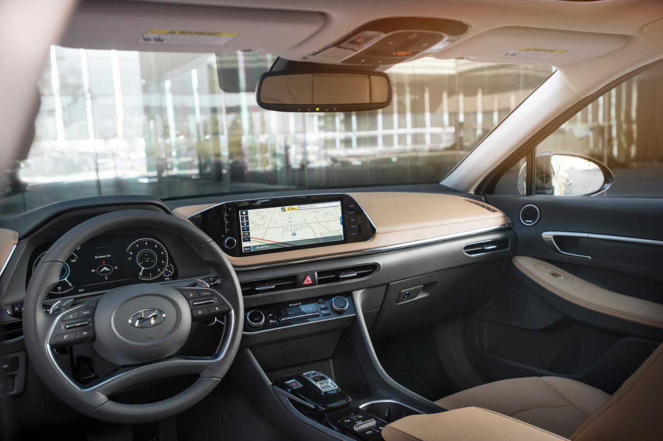

**Interior: “Beautifully Smart” Technology and Design**

The cabin conforms to a “Beautifully Smart” theme, aligned with the expectations of Sonata customers seeking advanced technologies applied naturally and intuitively. The signature aesthetic of the exterior lighting is echoed inside in the form of ambient mood lighting featured across the dashboard and doors.

Spanning the full width of the cabin, the slim dashboard features a first-in-class, 12.3-inch digital instrument cluster, which is customizable to suit different driving modes and preferences. At the center of the dashboard, a large, 10.25-inch HD screen enables occupants to interact easily with the audio-video and navigation (AVN) functions. This screen can also accommodate a split-screen function that allows audio and navigation to be displayed simultaneously. All Sonata models, except the entry model, include three years of complimentary Blue Link services.

The instrument panel is rich and modern, in the shape of spread wings, inspired by a stealth aircraft. This shape presents a levitating effect, and this philosophy carries into the long armrests. The satin chrome accents enhance this effect even further. Designers compressed the height of the dashboard and HVAC vents as much as possible to emphasize the lightweight feeling, while modern, light fabric colors and leathers provide a fresh and unconstrained ambience for the driver.

At the heart of the AVN system is an exceptional sound system, the first result of a new collaboration between Hyundai and Bose engineers. The Bose Premium sound system is equipped with 12 speakers that synchronize to deliver crisp and rich sounds for a high-quality audio experience. Audio and EQ adjustments are made automatically, depending on the vehicle’s speed, while Bose Centerpoint surround technology and Bose SurroundStage signal processing put every occupant at the center of the audio experience, regardless of where they are positioned in the cabin.

Maximizing the sense of a spacious interior was a key focus for Hyundai’s designers and engineers. Alongside visual devices that create an impression of greater room, the new Sonata features an optional panoramic sunroof that amplifies the light and airy ambience.

Wherever possible, Hyundai took the opportunity to combine a technological development with visual or space benefit. The new Shift by Wire (SBW) gear selector is a prime example, as the new interface not only is sleek and technologically advanced but also takes up significantly less space than a traditional gear selector.

**Safety**

The new Sonata maximizes occupant safety through a range of active and passive safety technologies. Passengers benefit from a comprehensive nine-airbag set-up, while a sophisticated Advanced Driver Assistance System (ADAS) works to alert drivers to things they might miss while driving.

**Performance and Chassis**

The all-new Sonata is the first model to utilize Hyundai Motor’s third-generation vehicle platform. Offering significant flexibility for vehicle development across multiple segments, the platform enables dramatic innovations in design, alongside improvements in safety, efficiency and driving performance.

The platform delivers an improvement in collision safety through the use of a multiload path structure, Hot Stamping, and super-high-tensile steel plate. The sophisticatedmultiload path structure increases the energy that the vehicle absorbs in collisions.

**Smartstream Powertrains**

Customers can choose between two Smartstream gasoline powertrains: a 2.5 GDI and a 1.6 T-GDI engine, both mated to an eight-speed automatic transmission. The new Smartstream G2.5 GDI engine, with high-efficiency combustion, cooled EGR and an optimized ITMS cooling system, boasts a generous 191 horsepower at 6,100 rpm and 181 lb.-ft. of torque at 4,000 rpm, plus an expected combined EPA estimated fuel economy of 33 mpg. Meanwhile, the new Smartstream G1.6 T-GDI has 180 horsepower at 5,500 rpm and 195 lb.-ft. of torque at 1,500–4,500 rpm and is expected to achieve an EPA estimated 31 mpg combined, thanks to its world-first Continuously Variable Valve Duration (CVVD) system.

|  |  |  |
| --- | --- | --- |
|  | **2020 2.5-liter** | **2019 2.4-liter** |
| **Horsepower** | **191 hp. (estimated)** | 185 hp. |
| **Torque** | **181 lb.-ft. (estimated)** | 178 lb.-ft. |
| **Fuel Economy** | **EPA estimated 33 combined (preliminary estimate)** | EPA estimated 29 combined |

**Driving Dynamics**

The driving performance goal for the 2020 Sonata was to create a sense of unity between the car and the driver. Combining the new platform and modern engines allows the car to respond quickly to the driver’s inputs and provide a quiet, solid ride on the highway. The driving dynamics match the sporty exterior design, and the steering and handling package is also improved, so the 2020 Sonata is more nimble than its predecessor.

Enhanced Front Suspension Geometry for Improved Responsiveness

* Reduced bump steer
* Improved roll steer linearity
* Reinforced front/rear subframe rigidity

Enhanced Rear Suspension Geometry for Enhanced Stability and Responsiveness

* Increased bump/roll steer
* Lowered rear roll center
* Added reinforcement bracket for rear cross member
* Optimized trailing arm shape/thickness

Braking responsiveness is also enhanced on the 2020 Sonata, thanks to a larger booster and increased delivery rate.

**Convenience Technology**

The 2020 Sonata features a number of advanced comfort and convenience features typically found only in luxury cars, including a sunroof, electric parking brake, smart trunk, Qi high-speed wireless smartphone charging pad with cooling fan, standard Apple CarPlay® and Android Auto®, Text-to-Speech via Bluetooth®, heated and ventilated front seats and split-folding rear seats.

The top-of-the-line audio and navigation display is a wide, high-definition, customizable, 10.25-inch touchscreen monitor with split screens and natural language, and cloud-based speech recognition powered by Blue Link, while the cluster supervision display is a full 12.3 inches. The cluster has four views: utility, driver assistance, navigation and parking assistance. The navigation system includes a bird’s-eye view in Navigation maps, and drivers get HERE HD Traffic flow and incident data without ever paying for a subscription. Dual Bluetooth support is also available, so two devices can be paired at the same time—one for phone calls and one for streaming audio. The navigation system also comes with three years of Blue Link Multimedia/Map updates. Hyundai’s eight-inch display audio user interface, equipped with Android Auto and Apple CarPlay, is standard on the 2020 Sonata. The Blue Link connected car system is also available.

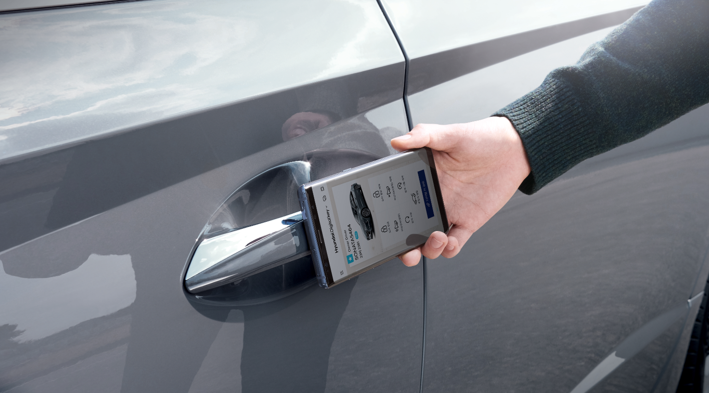

**Digital Key**

Continuing to promote the latest advances in technology, the new Sonata supports Hyundai Digital Key via a dedicated smartphone app. Hyundai Digital Key utilizes Near Field Communication (NFC) technology, which exhibits a high level of security. The NFC wireless data communication takes place only when the device and the reader are within several centimeters of each other. The Hyundai Digital Key app also allows smartphones to control selected vehicle systems remotely. Using Bluetooth Low Energy (BLE) communication, users can lock and unlock the vehicle, activate the panic alert and start the engine.

Not only does Hyundai Digital Key allow owners to leave traditional keys at home, it also allows secure sharing of keys with family and friends. The level of access to different vehicle functions can be tailored to each shared key user for a defined period. The vehicle owner can preset the duration of vehicle use or limit the use to only certain features when loaning the vehicle, and, of course, keys can be revoked remotely. For additional convenience in cases such as using a valet service or visiting a Hyundai dealer, Hyundai Digital Key also works with an NFC card, which will be provided with each vehicle. Each Sonata still comes with traditional keys. Digital Key is compatible only with phones using the Android operating system.

**Full Head-Up Display**

With a projected image size of eight inches and super-bright clarity (luminance of more than 10,000 candelas per square meter), the Sonata’s HUD provides improved visibility in different lighting conditions. The HUD can be adjusted in both angle and height to provide optimum visibility. The HUD supports driving safety by displaying information such as speed and navigation commands, as well as alerts from active safety and driving assistance features.

**Blue Link Enhancements**

The connected car team at Hyundai continues to improve Blue Link’s services, and the 2020 Sonata gets many system enhancements. As with most Hyundai models, Blue Link is complimentary on the 2020 Sonata for three years and includes Remote Start with Climate Control, Remote Door Lock/Unlock, Stolen Vehicle Recovery and Destination Search by Voice. These 2020 improvements include:

* Remote profile management—stores select vehicle settings to the Blue Link cloud, with the ability to remotely update them and push them back to the vehicle
* Remote start enhancements:
  + Remote seat heat/vent (full support on/off for each individual heated/cooled seat; ability to adjust level)  
    Profile selection (preloads individual driver settings for seating position and side mirrors)
* Vehicle Status Notifications—if the vehicle is left with doors unlocked or windows open, customers will receive a notification
* POI Send to Car now with Waypoints (ability to add up to three way points, to be delivered to the vehicle together and automatically set order of destinations)
* Maintenance Alert Enhancement—maintenance interval tracking is now visible in the multimedia system, with ability to reset

More details on specific Blue Link–equipped vehicles available at [**www.hyundaibluelink.com**](http://www.hyundaibluelink.com/).

**Driver Assistance Technologies**

Sonata features Hyundai’s latest SmartSense advanced driver assistance systems (ADAS). A series of sensors and systems, often restricted to luxury cars, combines to potentially warn the driver and may take action in the event of a safety incident. Meanwhile, other ADAS systems can help the driver perform certain tasks using the car’s three radar sensors, 12 ultrasonic sensors and five cameras. These features include:

* Forward Collision-Avoidance Assist (standard)
* Lane Keeping Assist (standard)
* Advanced Smart Cruise Control with Stop and Go (standard)
* Highway Driving Assist (optional)

**Highway Driving Assist**

Highway Driving Assist (HDA) is a driving convenience system that assists drivers in maintaining the center of the lane, at an appropriate speed, while keeping a safe distance to the car in front.

**Forward Collision-Avoidance Assist**

The 2019 Sonata is fitted with standard Forward Collision-Avoidance Assist (FCA) with pedestrian detection, an advanced active safety feature that helps alert drivers to emergency situations, and may brake autonomously, if required. Using front radar and front camera sensors, FCA operates in three stages. Initially warning the driver visually and acoustically, it assesses the nature of the collision danger and can apply increasing amounts of braking force to avoid a collision or minimize damage when a collision is unavoidable. The system is activated when a vehicle, pedestrian or cyclist is sensed in front of the car.

**Lane Following Assist**

Lane Following Assist (LFA) may automatically adjust steering to help keep the vehicle centered in its lane of travel. LFA can keep the vehicle centered on both highways and city streets.

**Safe Exit Assist**

Safe Exit Assist helps prevent accidents should a door be opened when another vehicle is approaching from behind. Using the radar, the system may detect approaching vehicles and warn the driver when a door is opened.

**Blind-Spot View Monitor and Blind-Spot Collision Warning (BCW)**

The Blind-Spot View Monitor with the Sonata’s outside mirror-mounted cameras offers the driver an enhanced field of vision. The Blind-Spot Collision Warning (BCW) system scans for vehicles entering your blind spot. If the driver activates a turn signal, an image of the view from the corresponding wing mirror is displayed in the 12.3-inch cluster display. If a vehicle is detected in the blind spot, audible and visual alerts are provided.

**Surround-View Monitor**

The new Sonata uses four cameras to provide the driver with an enhanced, bird’s-eye view of the car’s exterior, giving the driver confidence when maneuvering into or out of spaces.

**Reverse Parking Collision-Avoidance Assist**

Reverse Parking Collision-Avoidance Assist helps detect pedestrians and obstacles with a rearview camera and ultrasonic sensors. The system can provide warnings and apply emergency braking to assist in the avoidance of a collision.

**Remote Smart Parking Assist**

In a first for its class, the new Sonata offers Remote Smart Parking Assist to help maneuver the car into or out of parking spaces, boosting convenience for customers. Before a driver attempts to load load passengers or luggage, the remote parking function can prove particularly useful, bringing the vehicle out of a tight space. The driver simply uses the smart key to drive the car forward or backward, into or out of a parking space.

**Touch Sensor Outside Door Handles**

Touch Sensor Outside Door Handles have been added to the 2020 Sonata to increase ease of use and further refine the design. To lock the door, the driver need only touch the sensor on the outside of the door handle. Pulling on the handle activates a larger sensor on the inside of the handle to open the door.

**Remote Start**

Remote Starthas been a part of the Hyundai Blue Link system for years. It works by using a cellular data connection to warm up or cool down a Sonata when it is out of sight of the owner. To make that system even better, Hyundai engineers added Remote Start to the 2020 Sonata’s key fob on models equipped with Proximity Key and Push Button Start. This allows a remote start to be performed when the car is within the owner’s line of sight.

**HYUNDAI MOTOR AMERICA**

Hyundai Motor America is focused on delivering an outstanding customer experience grounded in design leadership, engineering excellence and exceptional value in every vehicle we sell. Hyundai’s technology-rich product lineup of cars, SUVs and alternative-powered electric and fuel cell vehicles is backed by Hyundai Assurance—our promise to deliver peace of mind to our customers. Hyundai vehicles are sold and serviced through more than 830 dealerships nationwide, with the majority sold in the U.S. built at U.S. manufacturing facilities, including Hyundai Motor Manufacturing Alabama. Hyundai Motor America is headquartered in Fountain Valley, California, and is a subsidiary of Hyundai Motor Company of Korea.

Please visit our media website at [www.HyundaiNews.com](http://www.HyundaiNews.com)

Hyundai Motor America on [Twitter](http://twitter.com/hyundai) | [YouTube](http://www.youtube.com/hyundai) | [Facebook](http://www.facebook.com/Hyundai) | [Instagram](http://www.instagram.com/hyundaiusa)

- End -

**Contact**Miles Johnson   
(714) 366-1048  
[milesjohnson@hmausa.com](mailto:milesjohnson@hmausa.com)

**Disclaimer:** Hyundai Motor America believes the information contained herein to be accurate at the time of release. However, the company may upload new or updated information if required and assumes that it is not liable for the accuracy of any information interpreted and used by the reader.